Ideation Phase

Define the Problem Statements

|  |  |
| --- | --- |
| Date | 8 NOVEMBER 2022 |
| Team ID | PNT2022TMID47056 |
| Project Name | Smart Fashion Recommender Application |
| Maximum Marks | 2 Marks |

**Customer Problem Statement Template:**

Create a problem statement to understand your customer's point of view. The Customer Problem Statement template helps you focus on what matters to create experiences people will love.

A well-articulated customer problem statement allows you and your team to find the ideal solution for the challenges your customers face. Throughout the process, you’ll also be able to empathize with your customers, which helps you better understand how they perceive your product or service.

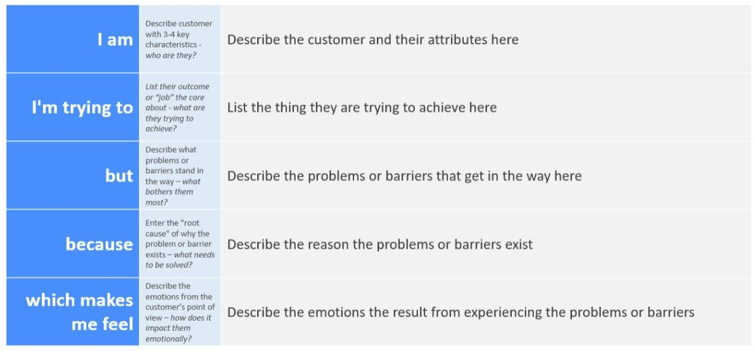

|  |  |  |  |  |  |
| --- | --- | --- | --- | --- | --- |
| **Problem**  **Statement (PS)** | **I am**  **(Customer)** | **I’m trying to** | **But** | **Because** | **Which makes me feel** |
| PS-1 | I am a student | I am trying to buy a formal dress for  college event | I can’t find perfect  match | Either the brand or colour  doesn’t suit | I don’t have any choice in choosing right brand. |
| PS-2 | I am a bride | Looking for wedding and reception dress | Could not able to choose right  dress | Availability of wide variety of products | Like I’m overthinking regarding how my dress should looks like. |
| PS-3 | I am an  Average Man | Buy clothes to attend family function. | could not find dress of my  desire | Product price not within the budget | Give up and move for other ecommerce site |

